**CHEMICAL INFORMATION MANAGEMENT SYSTEM C.I.M.S**



**DEPARTMENT OF OCCUPATIONAL SAFETY AND HEALTH (DOSH) MARCH 2011**

**User Manual for Head of Section Module**

Chemical Information Management System

Department of Occupational Safety and Health Malaysia

**CONTENTS**

**USER MANUAL FOR HEAD OF SECTION MODULE ..................................................................... 2**

CHEMICAL INFORMATION MANAGEMENT SYSTEM ................................................................................. 2

**MAIN SCREEN...................................................................................................................................... 3**

**LOGIN.................................................................................................................................................... 3**

**HOME .................................................................................................................................................... 4**

NEW SUBMISSION: WAITING FOR ACKNOWLEDGE ............................................................................................ 5

NEW SUBMISSION: ACKNOWLEDGE ....................................................................................................... 7

NEW SUBMISSION: REJECTED ................................................................................................................ 9

RENEWAL SUBMISSION: WAITING FOR ACKNOWLEDGE ........................................................................ 11

RENEWAL SUBMISSION: ACKNOWLEDGE ............................................................................................. 12

RENEWAL SUBMISSION: REJECTED ...................................................................................................... 14

NEW CHEMICAL ................................................................................................................................. 16

**INVENTORY ....................................................................................................................................... 17**

SUB MENU ......................................................................................................................................... 18

ACTIVITY BUTTON.............................................................................................................................. 18

CHEMICALS LIST ................................................................................................................................ 18

SYNONYM LIST................................................................................................................................... 19

CLASSIFIED CHEMICALS ............................................................................................................................ 20

UNCLASSIFIED CHEMICALS ........................................................................................................................ 21

**SUBMISSION .......................................................................................................................................... 22**

SUB MENU ............................................................................................................................................ 23

ACTIVITY BUTTON ................................................................................................................................... 23

ALL SUBMISSION: LIST ............................................................................................................................. 24

NEW SUBMISSION: ALL LIST ...................................................................................................................... 26

RENEWAL SUBMISSION: ALL LIST ................................................................................................................ 29

**REPORT .................................................................................................................................................. 30**

**PROFILE.................................................................................................................................................. 31**

**Main screen**

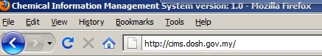

Web address: <http://cims.dosh.gov.my>

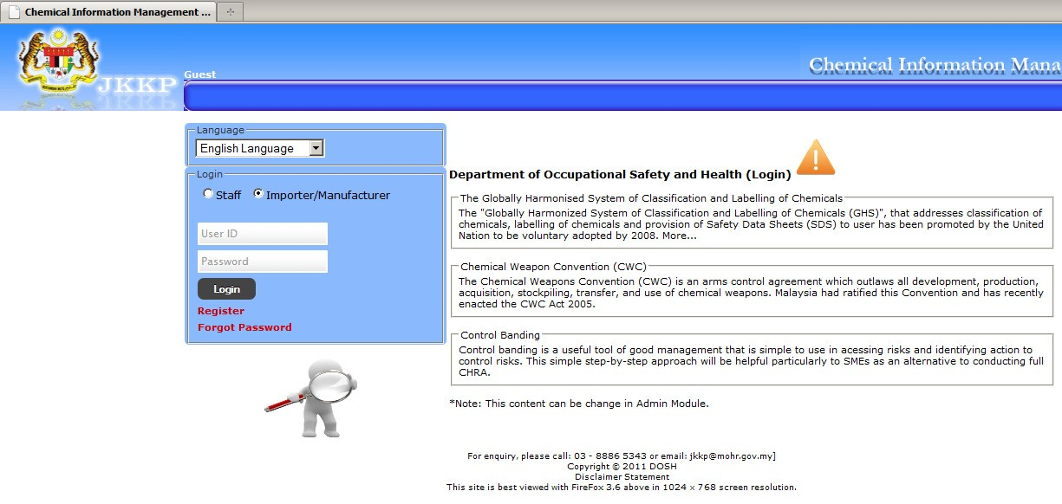

Home screen

**Login**

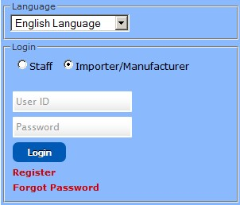

**Home**

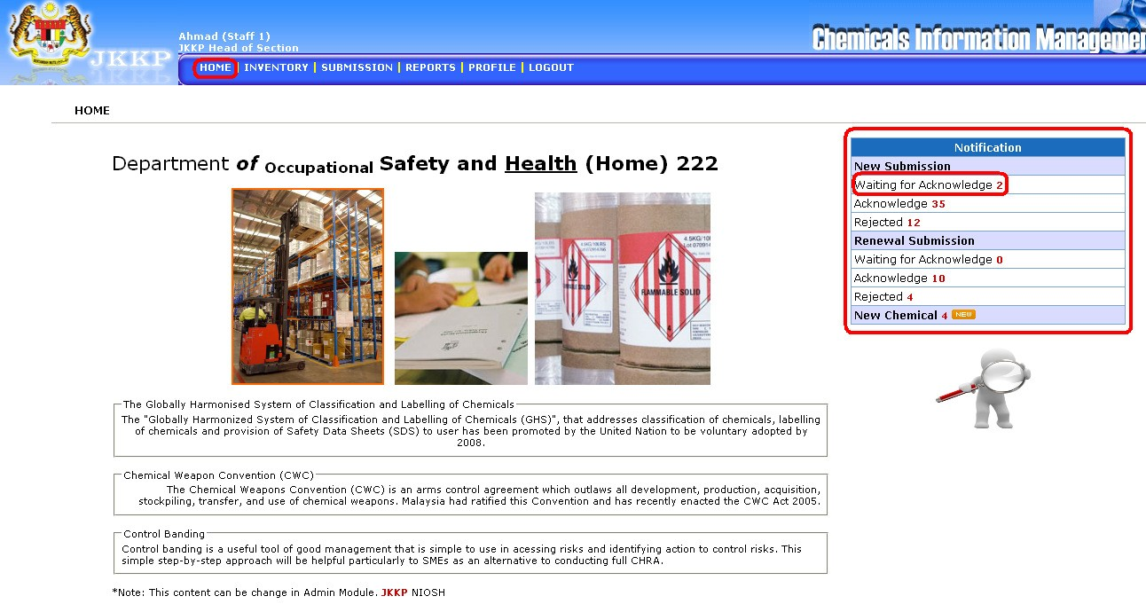

Home screen for Head of Section

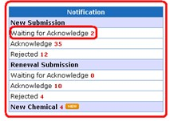

Notification shortcut for submission and new status

Search chemical information



***New Submission: Waiting for Acknowledge***

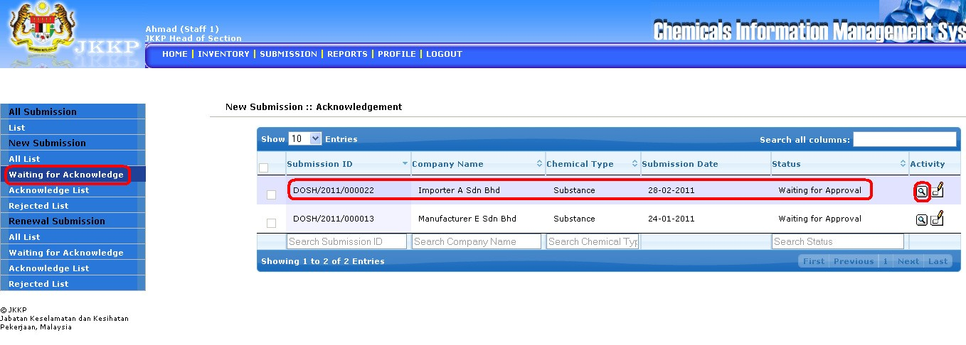

• List of waiting for acknowledge new submission

• Click View button

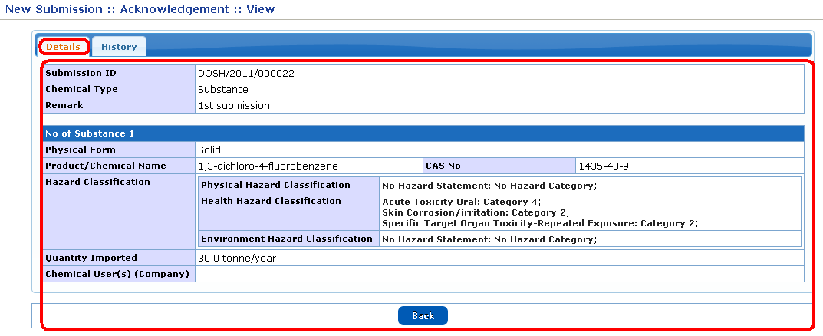

• Details of waiting for acknowledge new submission

• History of waiting for acknowledge new submission

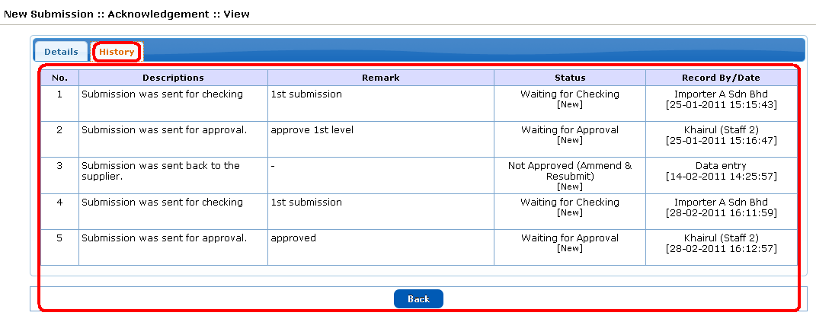

• Click Acknowledge button

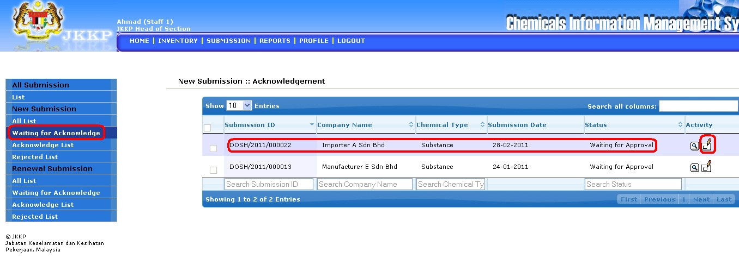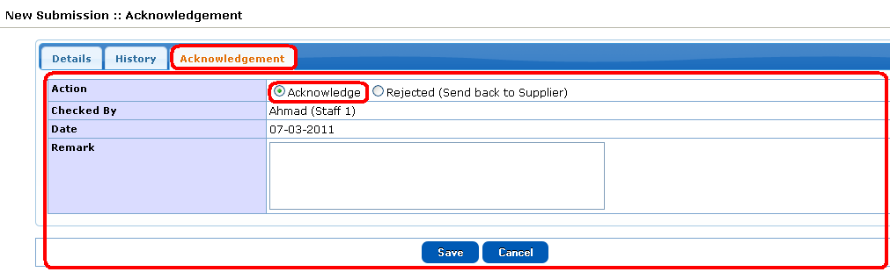

• Click Acknowledge radio button after acknowledge the acknowledge list new submission

• Click Rejected radio button to reject the list

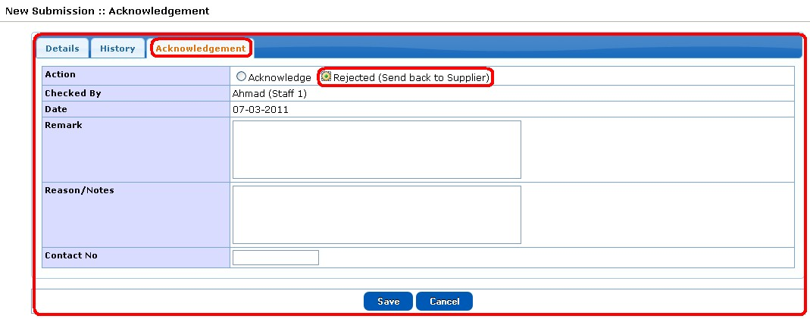

***New Submission: Acknowledge***

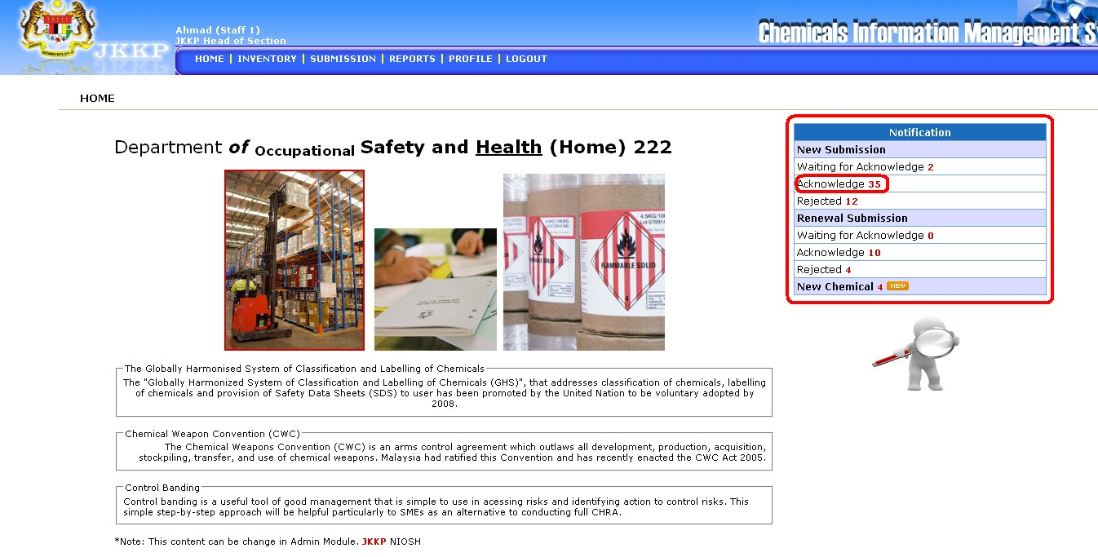

• List of acknowledge list new submission

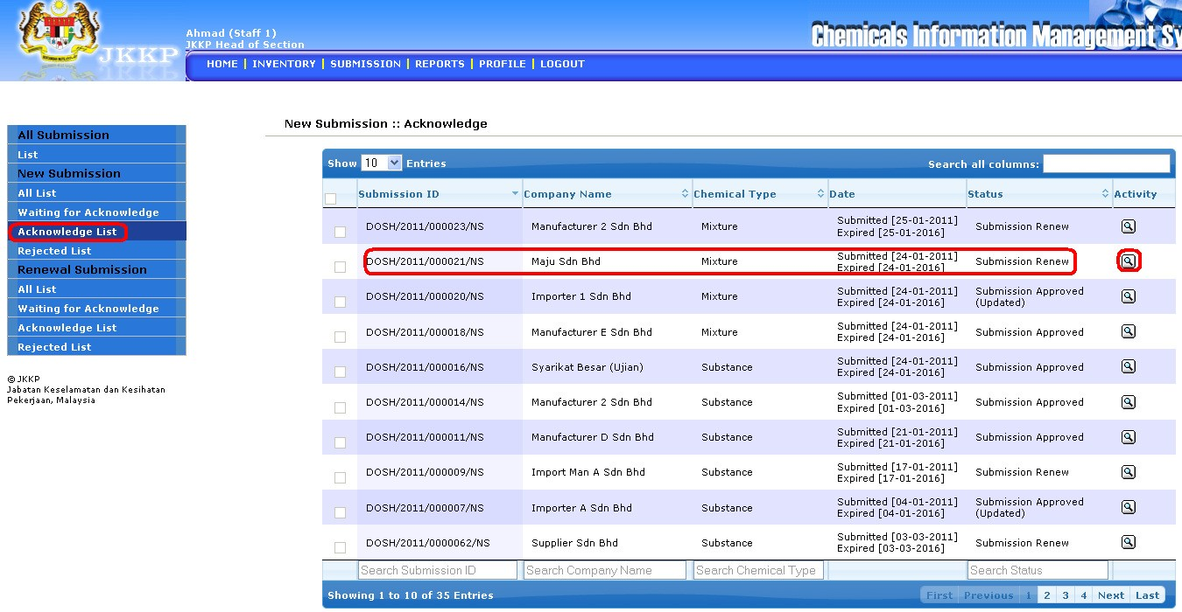

• Click view button

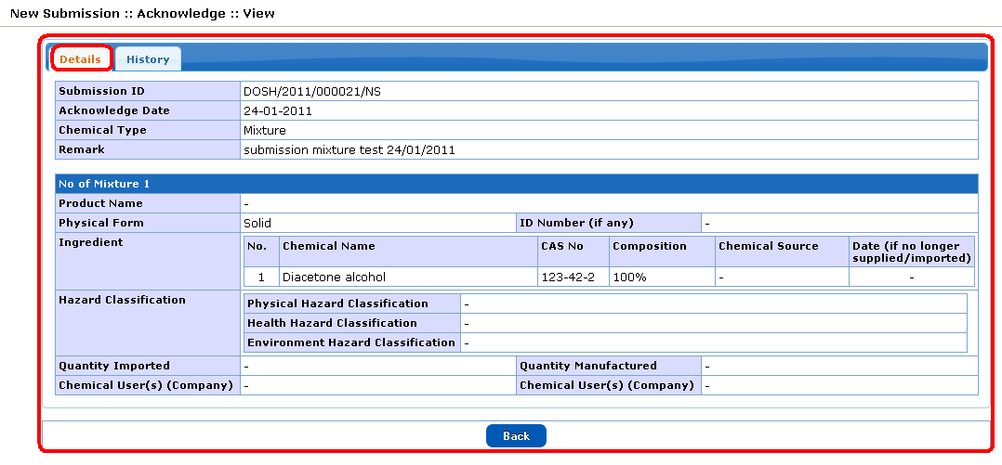

• Details of acknowledge list new submisssion

• History of acknowledge list new submisssion

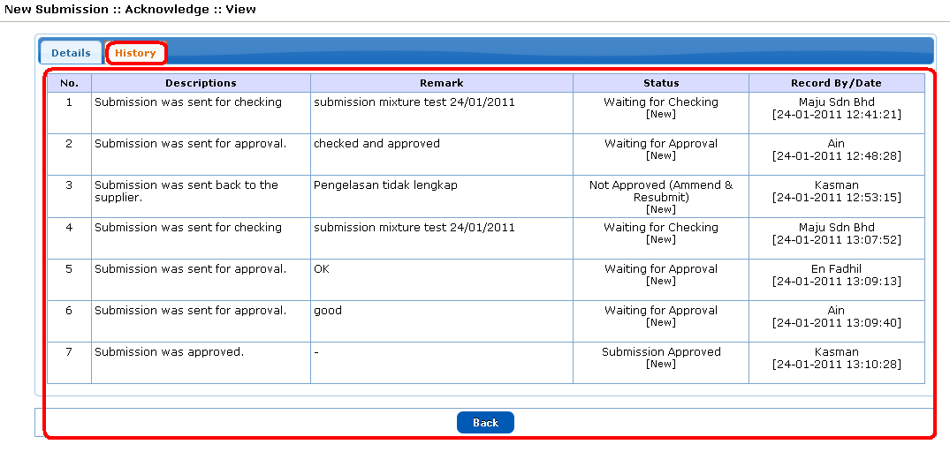

***New Submission: Rejected***

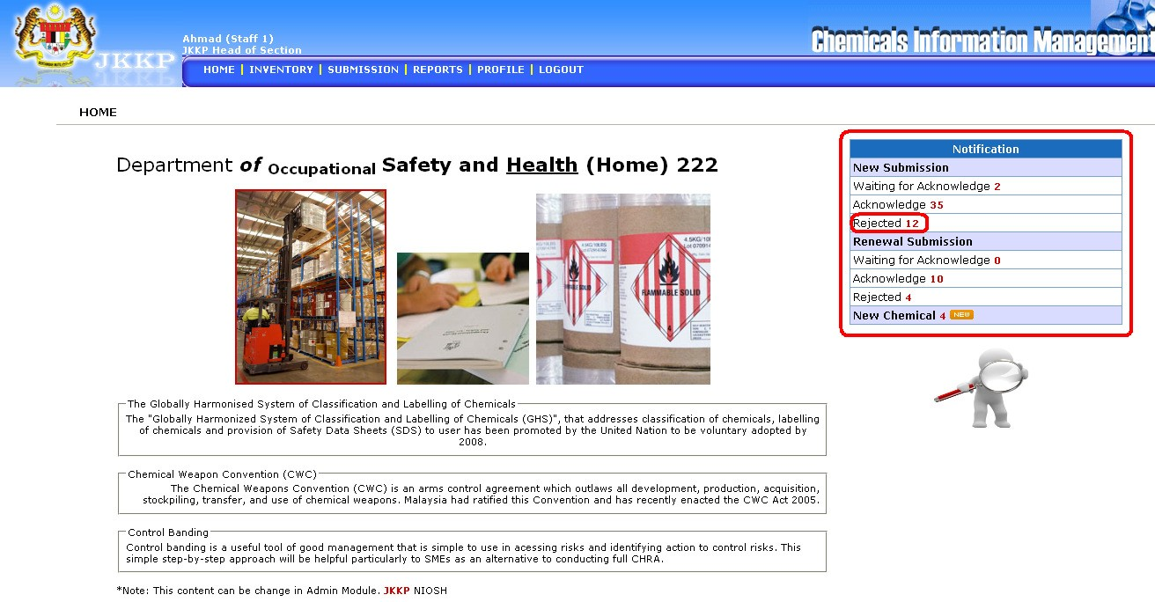

• List of rejected new submission

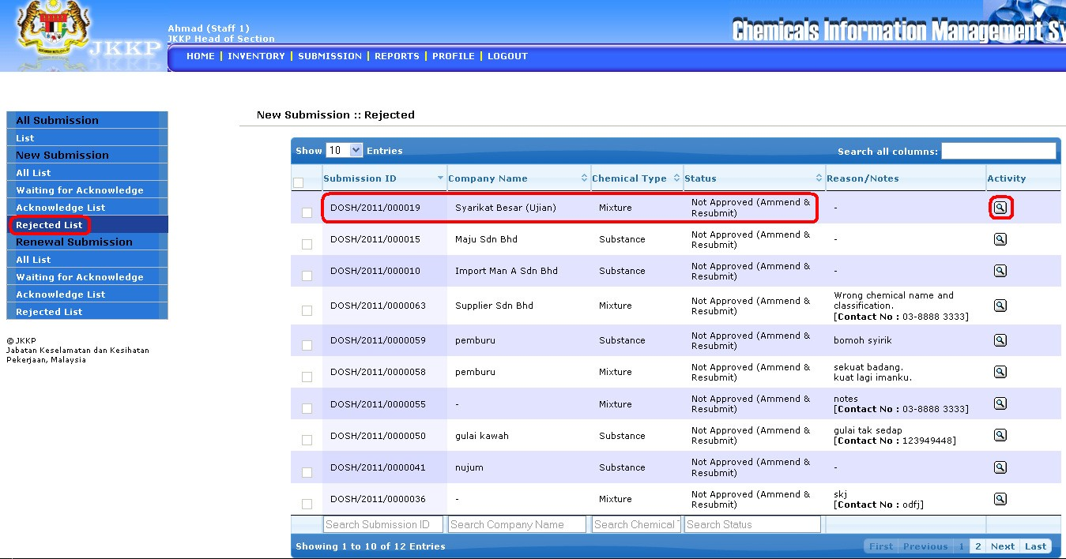

• Click view button

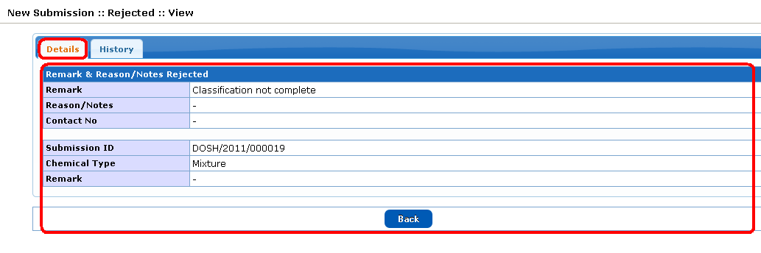

• Details for rejected list new submission

• History for rejected list new submission

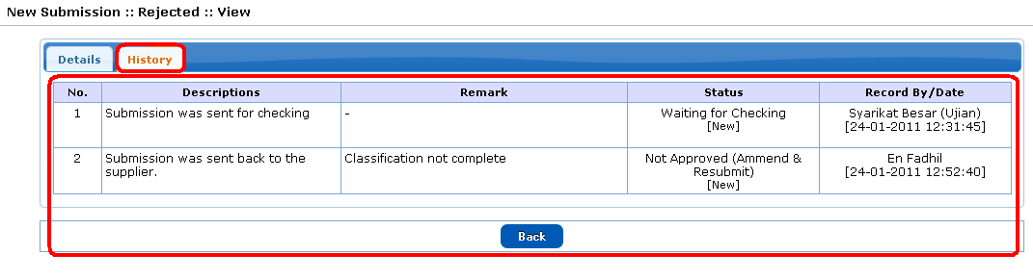

***Renewal Submission: Waiting for Acknowledge***

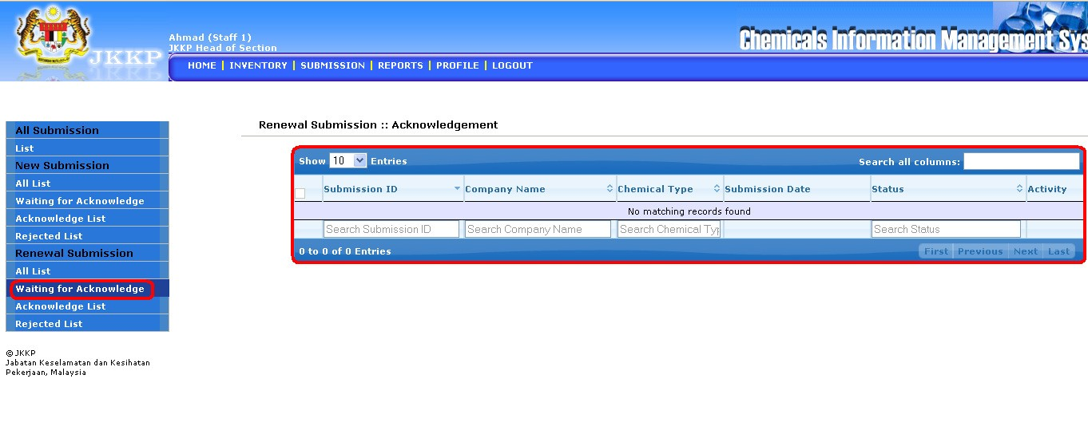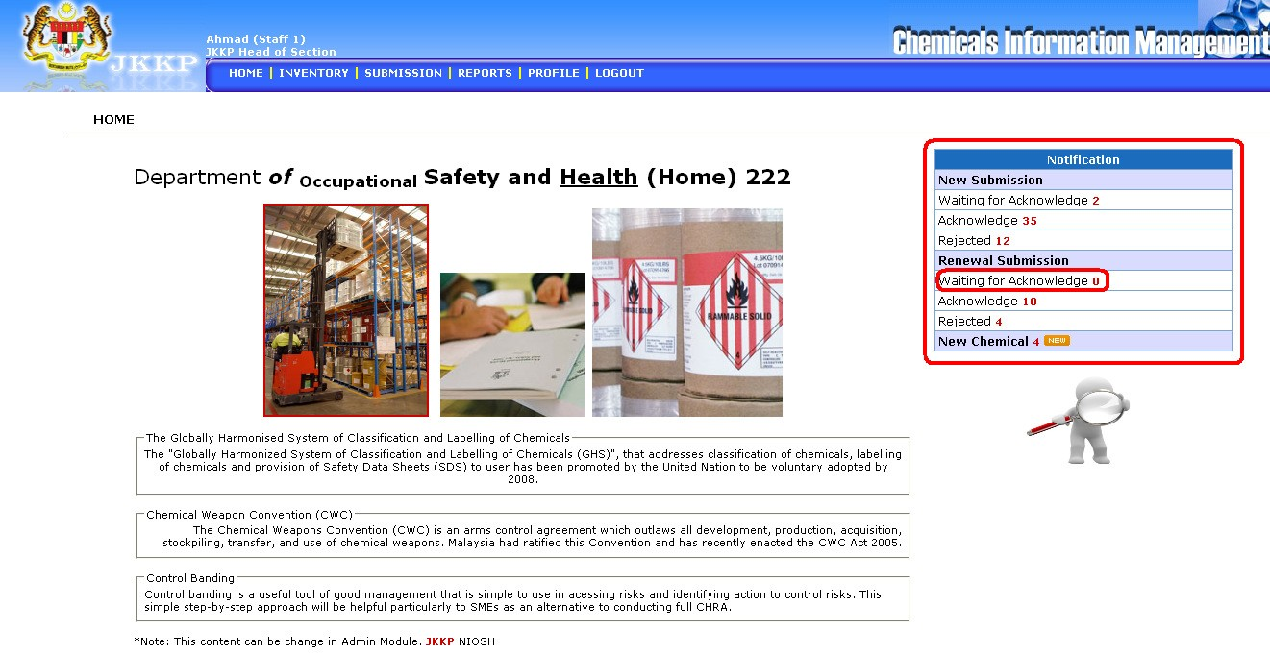

• List of waiting for acknowledge renewal submission

***Renewal Submission: Acknowledge***

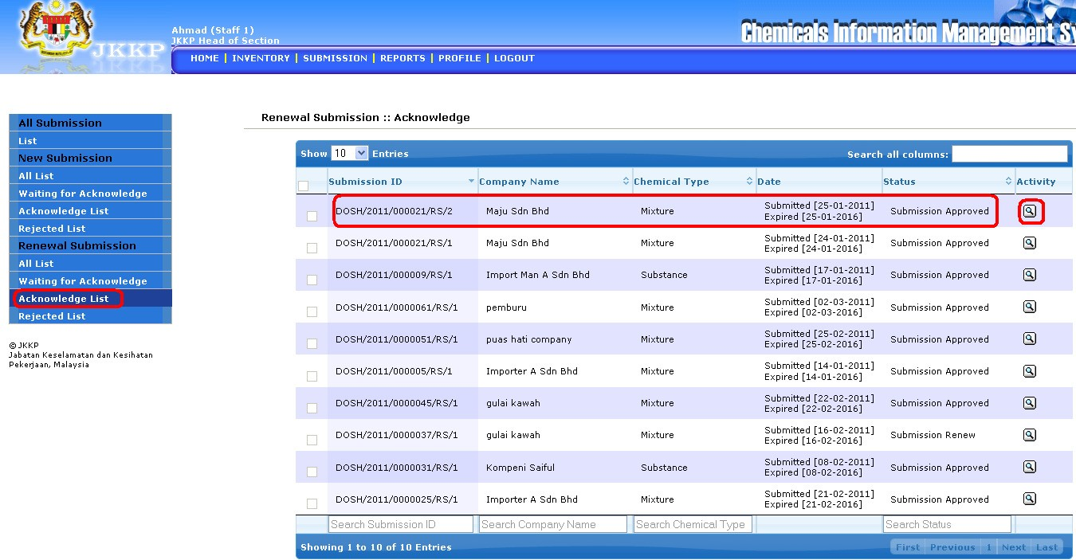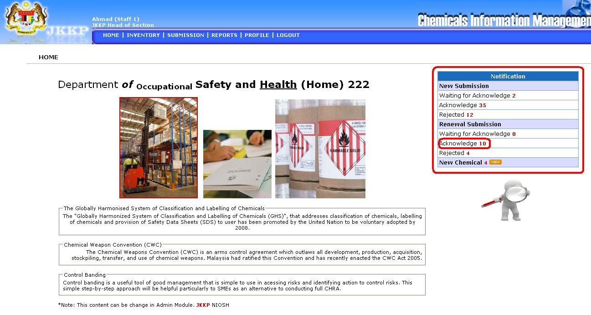

• List of acknowledge list renewal submission

• Click view button



• Details for acknowledge list renewal submission

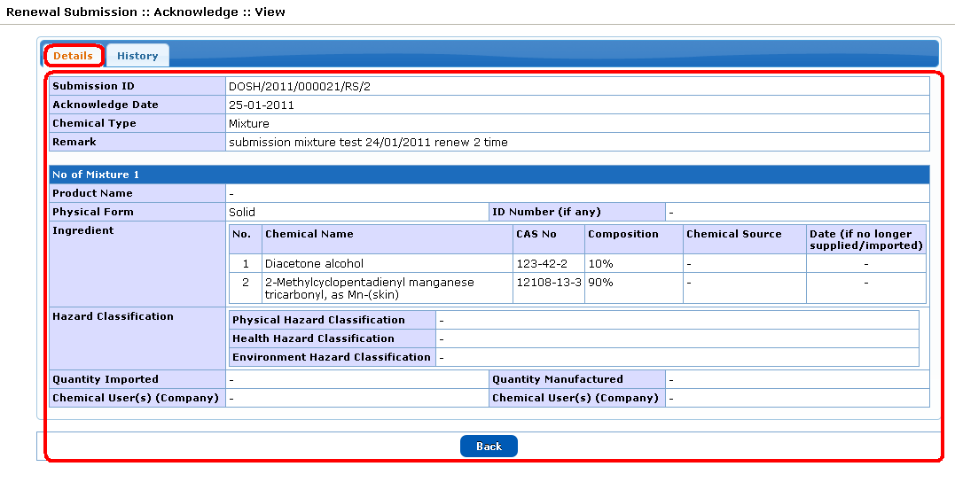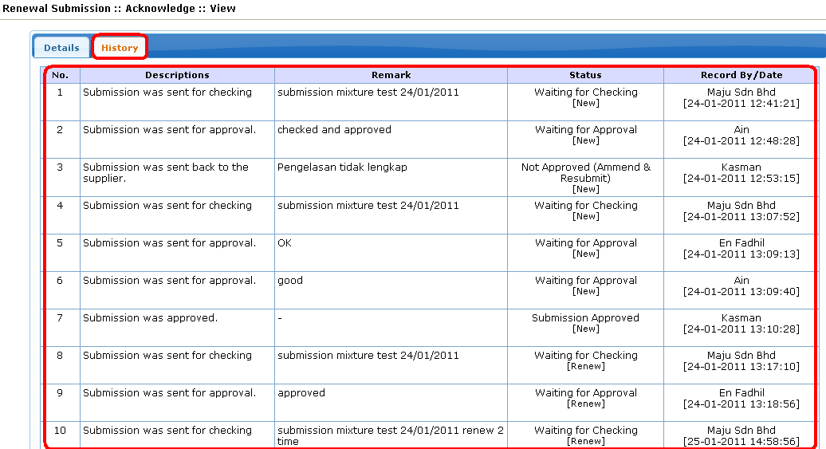

• History for acknowledge list renewal submission

***Renewal Submission: Rejected***

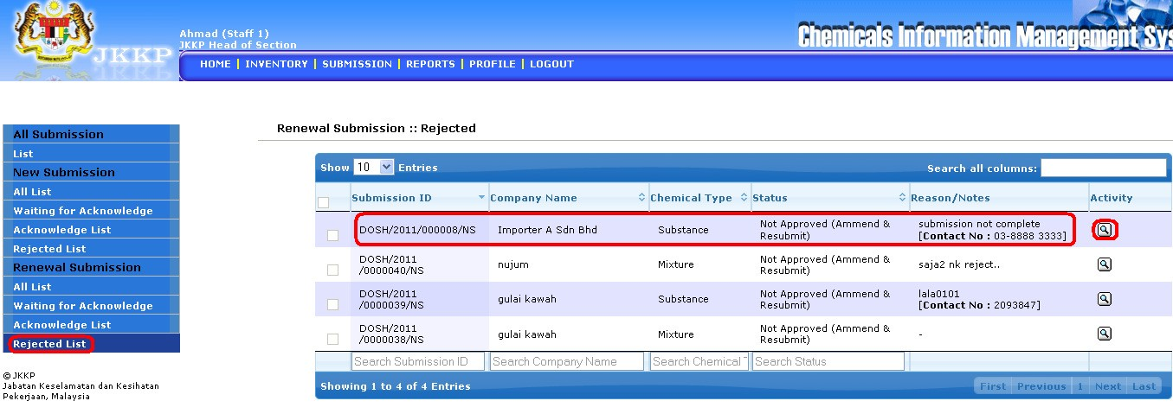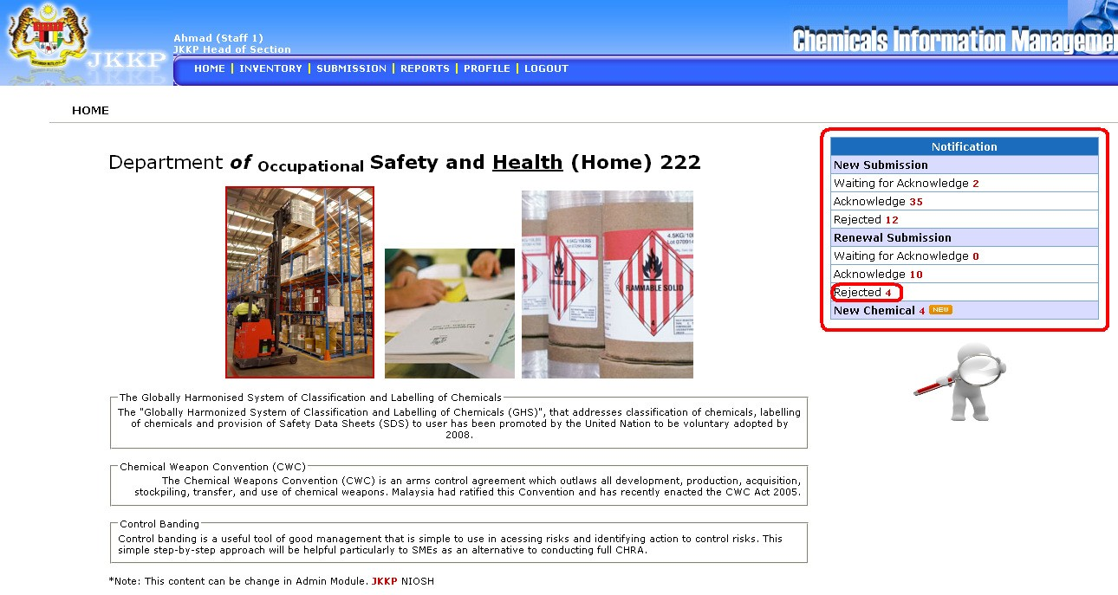

• List of Rejected list renewal submission

• Click View button



• Details for rejected list renewal submission

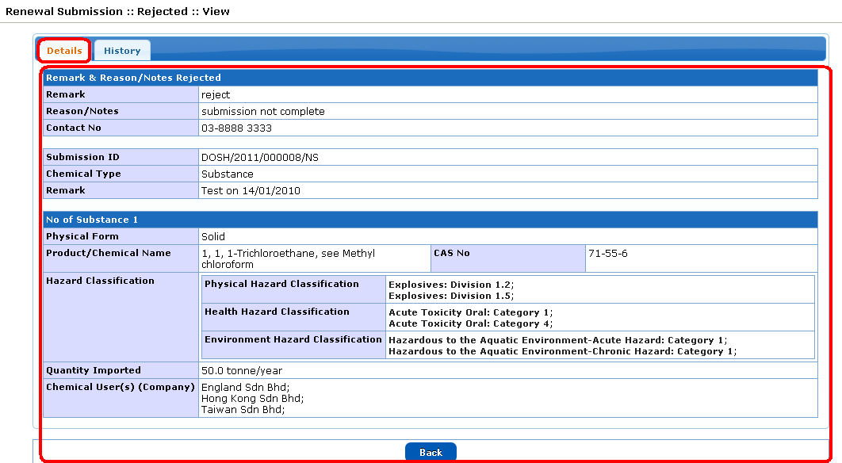

• History for rejected list renewal submission

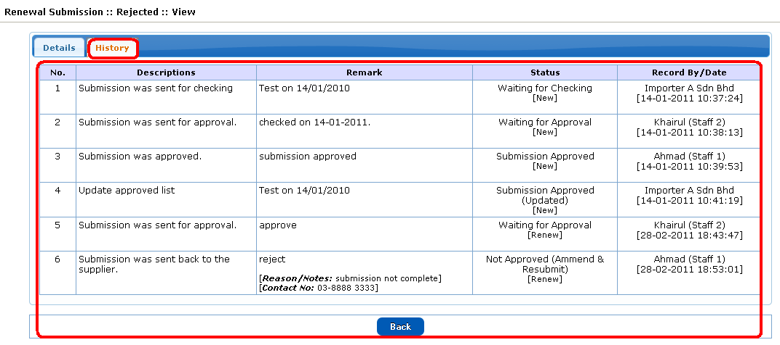

***New Chemical***

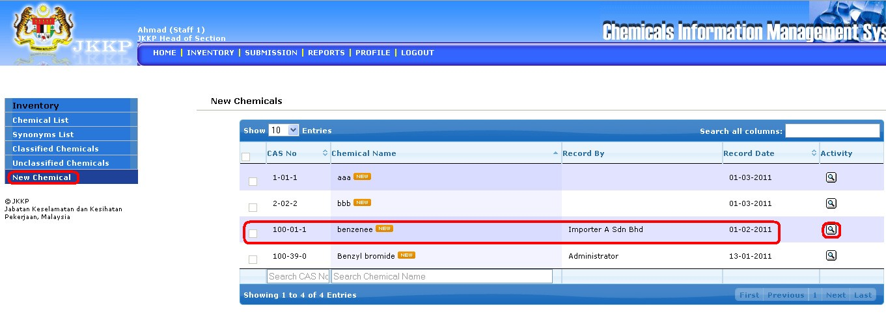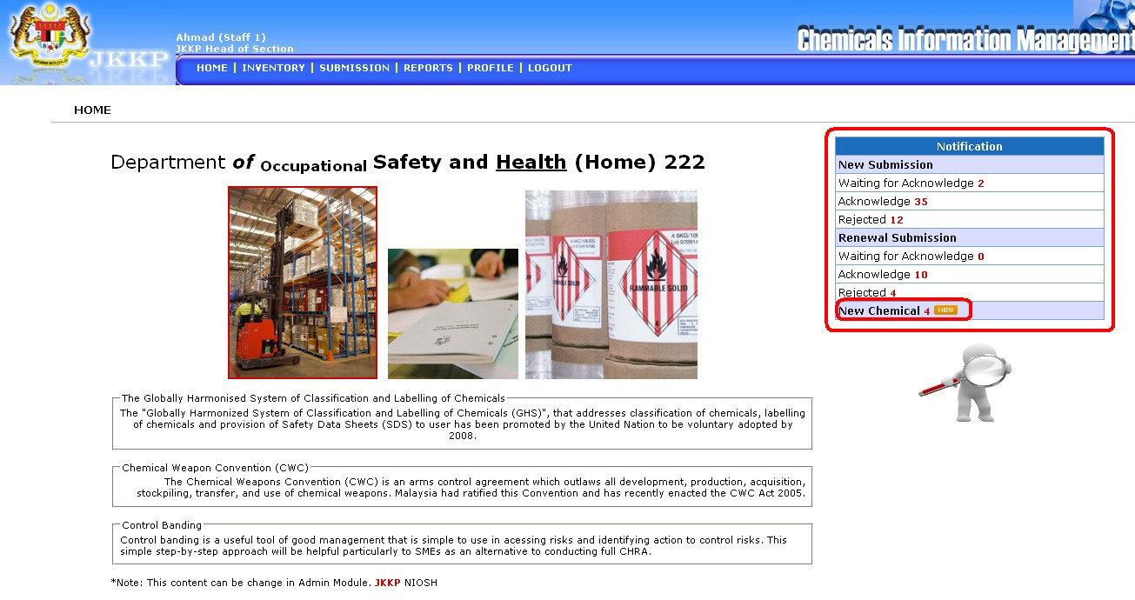

• List of new chemical

• Click View button

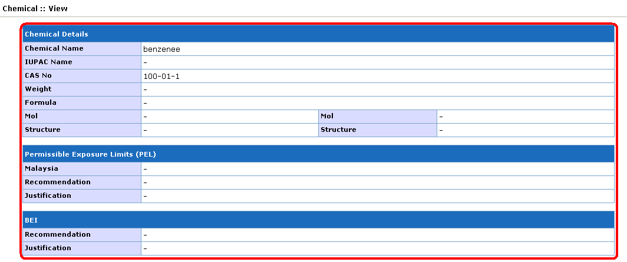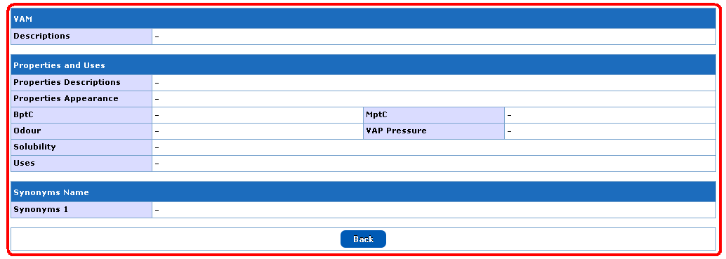

• View of new chemical details

**Inventory**

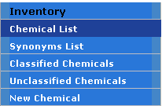

Inventory sub menu

***Sub Menu***

|  |  |  |
| --- | --- | --- |
| **No** | **Menu button** | **Descriptions** |
| **Inventory** | | |
| 1 | Chemical List | List all chemical list |
| 2 | Synonym List | List all synonym list |
| 3 | Classified Chemicals | List all classified chemicals |
| 4 | Unclassified Chemicals | List all unclassified chemicals |
| 5 | New Chemical | List all new chemical |

***Activity Button***



|  |  |  |
| --- | --- | --- |
| **No** | **Button** | **Descriptions** |
| 1 |  | View record details |
| 2 |  | Download records/certificate |

***Chemicals List***

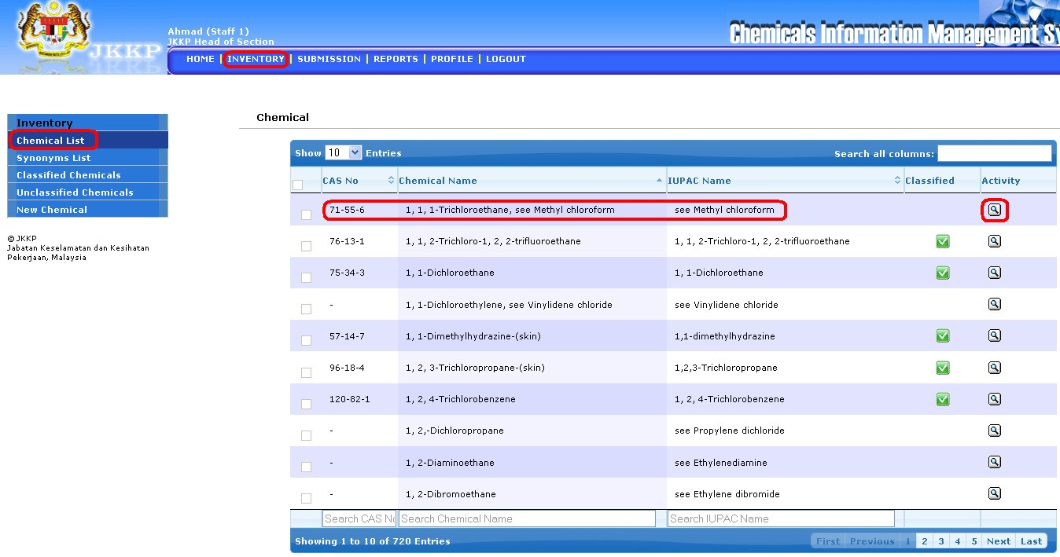

• List of chemical

• Click View button

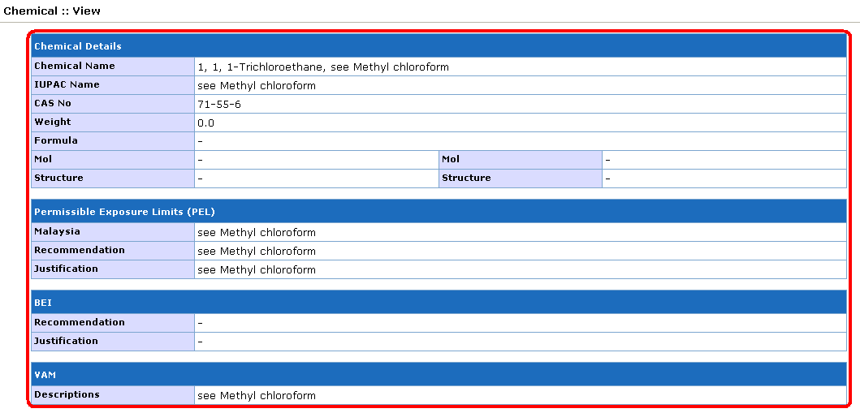

• View of chemicals list details

***Synonym List***

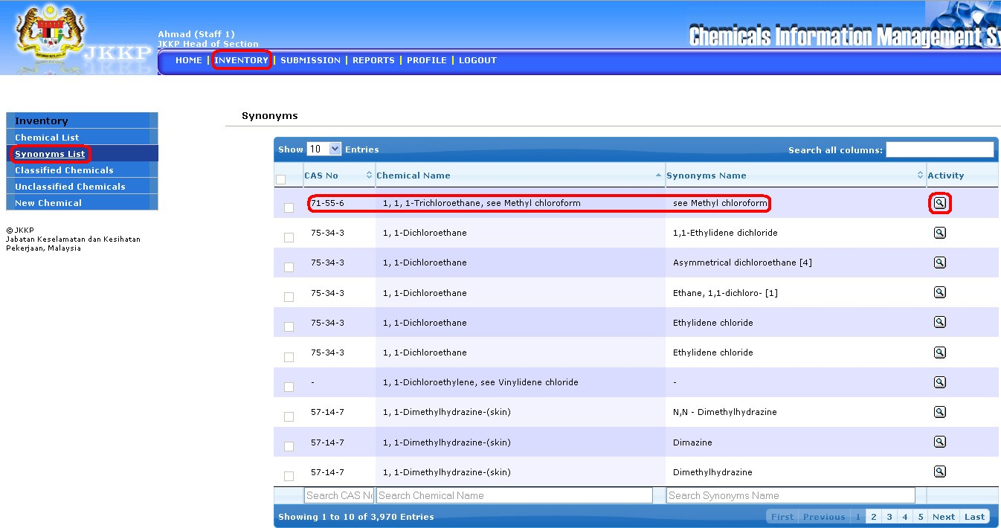

• List of synonyms chemical name

• Click View button



• View of synonym name

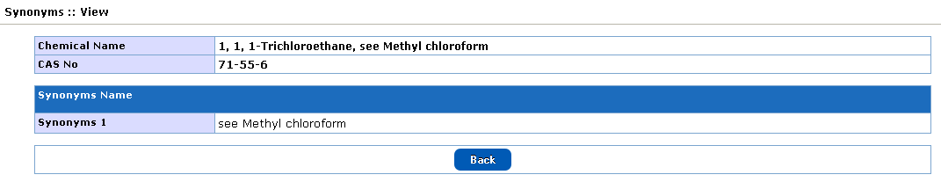

***Classified Chemicals***

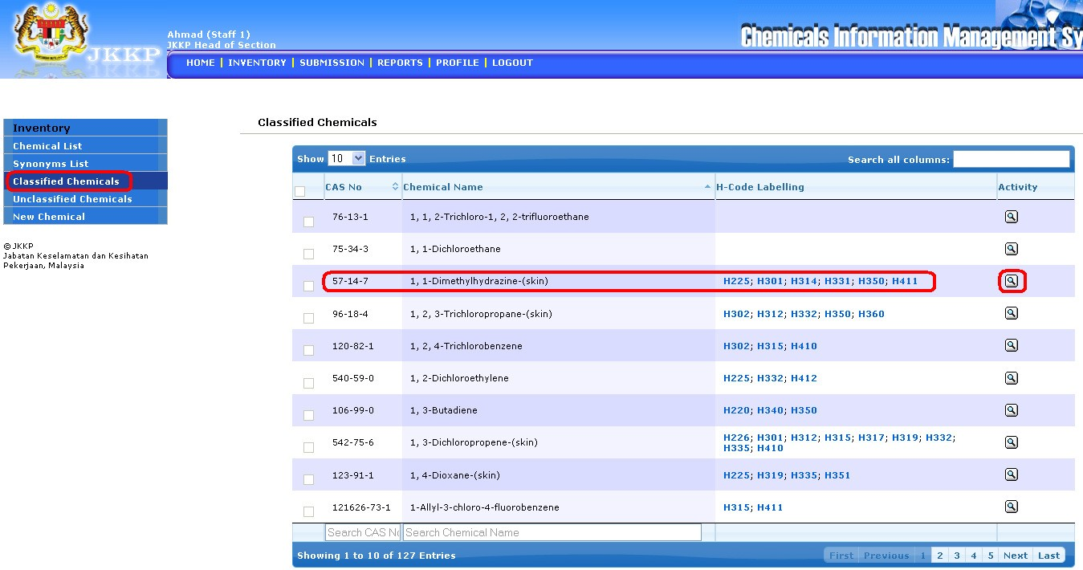

• List of classified chemicals

• Click View button



• View of classified chemicals

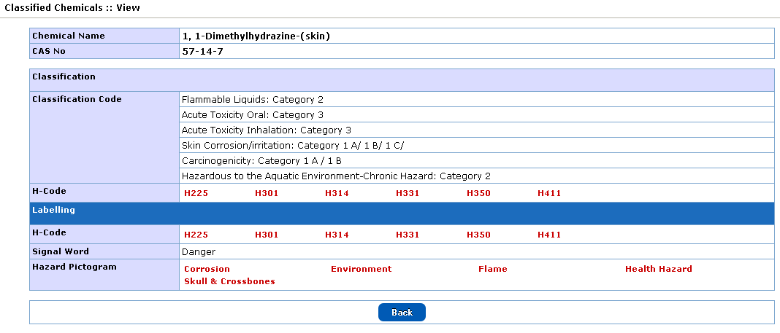

***Unclassified Chemicals***

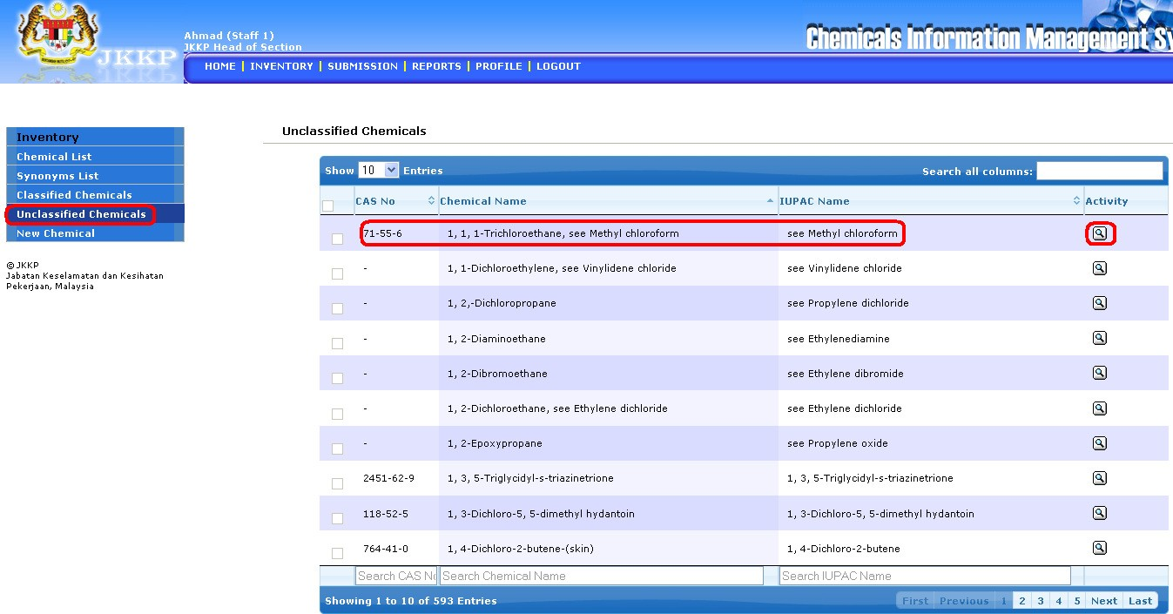

• List of unclassified chemicals

• Click View button



• View of unclassified chemicals details

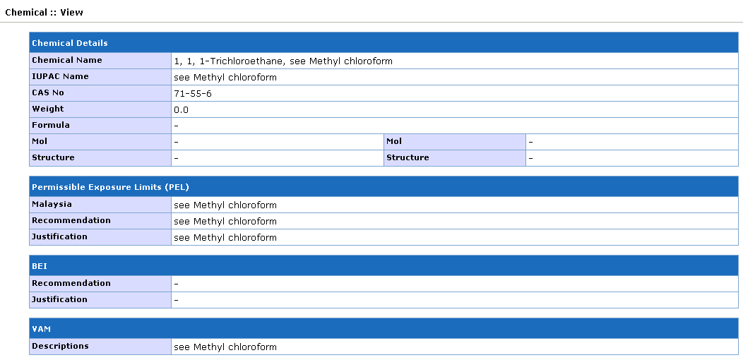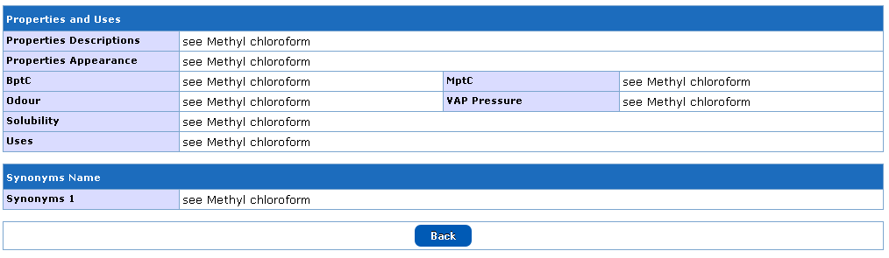

**Submission**

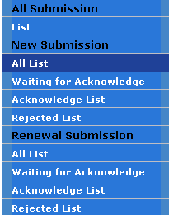

***Sub menu***

|  |  |  |
| --- | --- | --- |
| **No** | **Menu button** | **Descriptions** |
| **All Submission** | | |
| 1 | List | List all submission with status |
| **New Submission** | | |
| 2 | All List | List all new submission only with status |
| 3 | Waiting for Acknowledge | List new submission which is waiting for acknowledge |
| 4 | Acknowledge List | List all acknowledge submission |
| 5 | Rejected List | List all rejected submission |
| **Renewal Submission** | | |
| 6 | All List | List all renewal submission only with status |
| 7 | Waiting for Acknowledge | List renewal submission which is waiting for acknowledge |
| 8 | Acknowledge List | List all acknowledge submission |
| 9 | Rejected List | List all rejected submission |

***Activity Button***



|  |  |  |
| --- | --- | --- |
| **No** | **Button** | **Descriptions** |
| 1 |  | View record details |
| 2 |  | Acknowledge list |
| 3 |  | Download records/certificate |

***All Submission: List***

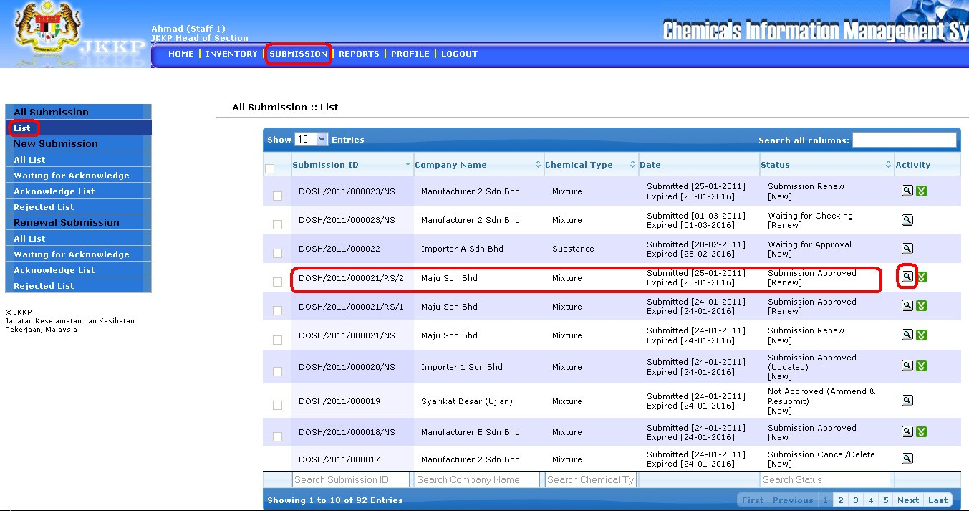

• List of all submission list

• Click View button

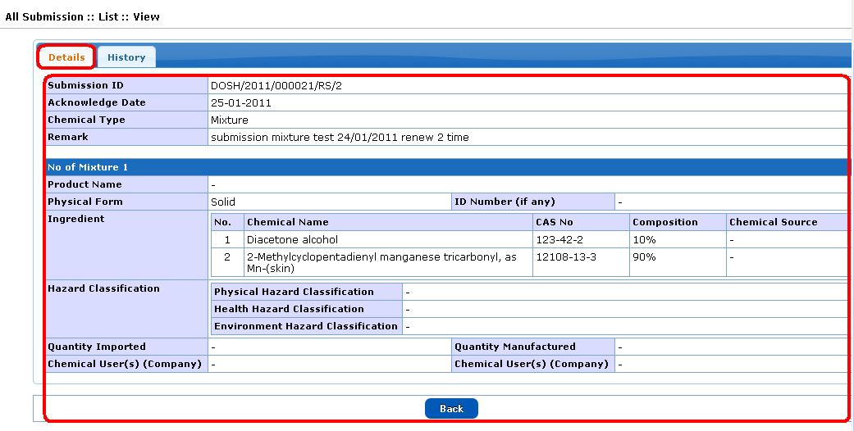

• Details of list all submission

• History of list all submisssion

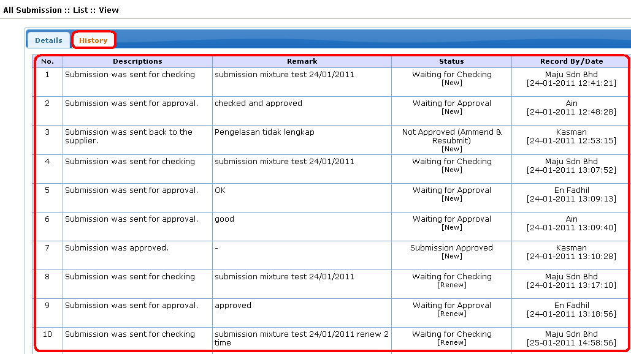

• Click download button

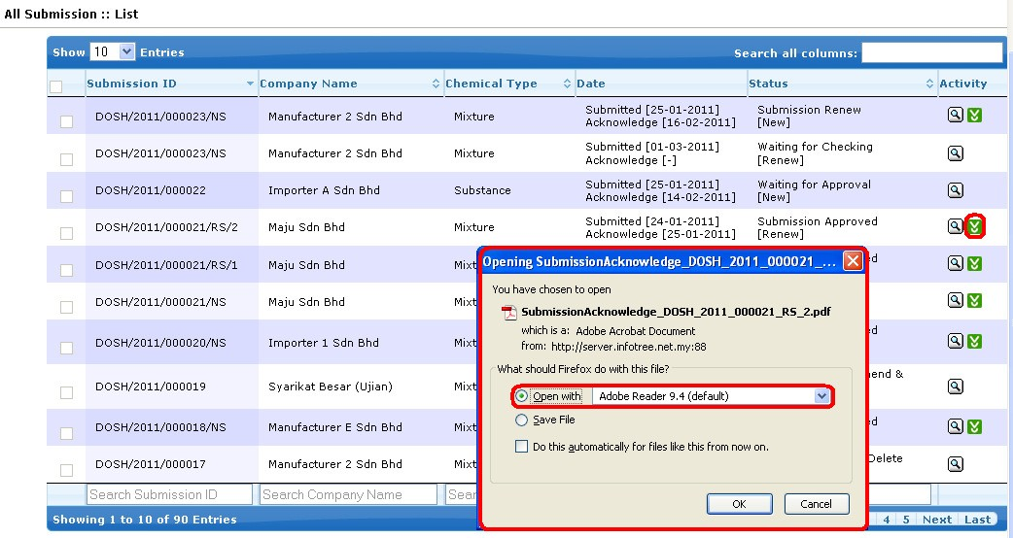

• Select open with or save file

• View report of list all submission

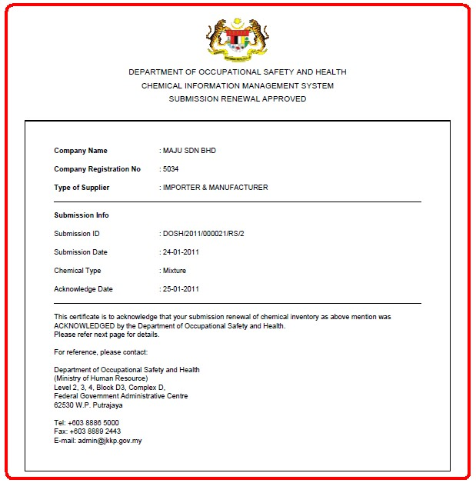

***New Submission: All List***

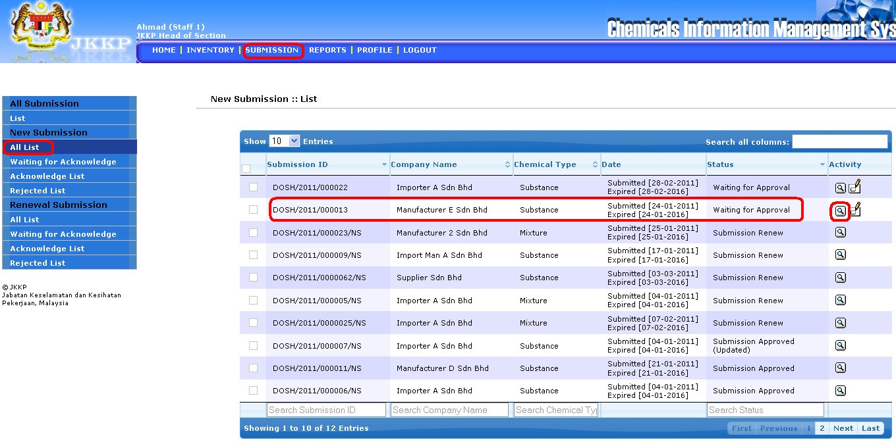

• List of all list new submission

• Click View button



• Details of all list new submission

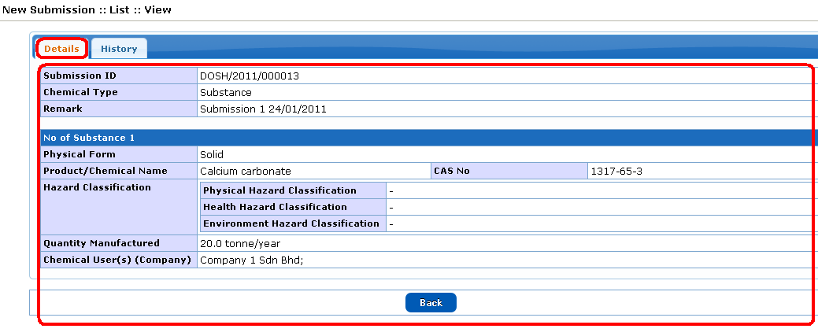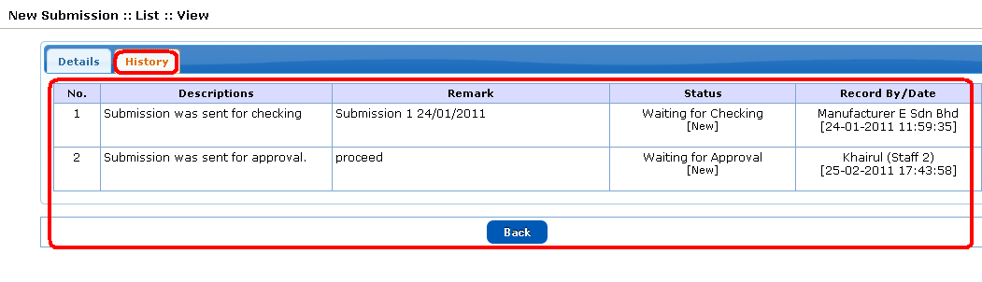

• History of all list new submission

• Click Acknowledge button

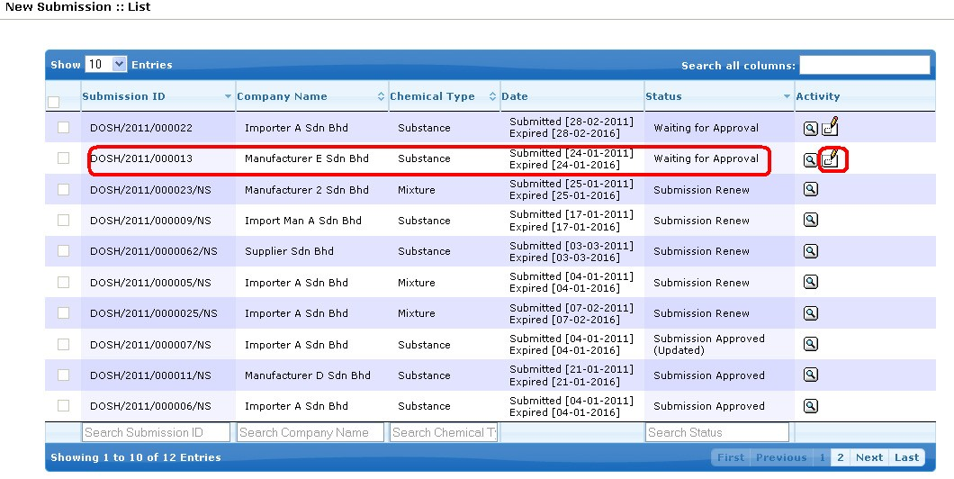

• Click Acknowledge radio button after acknowledge the acknowledge list new submission

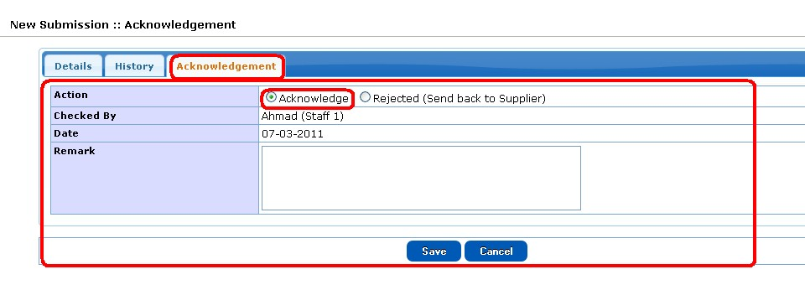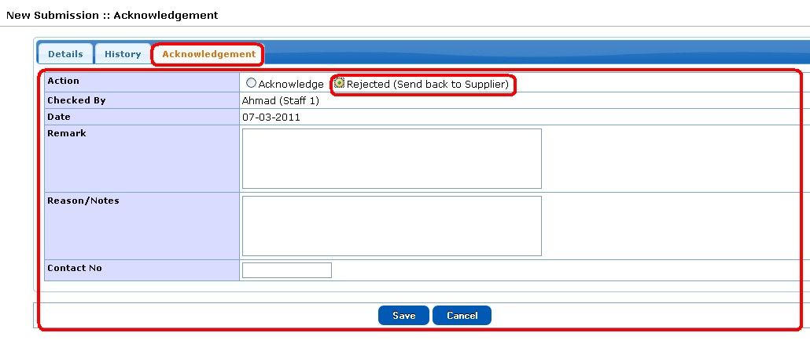

• Click Rejected radio button to reject the list new submission

***Renewal Submission: All List***

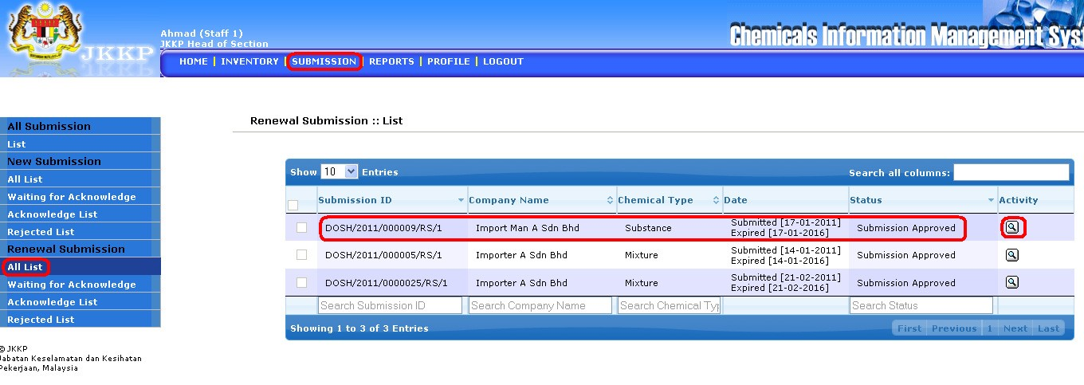

• List of all list renewal submission

• Click View button

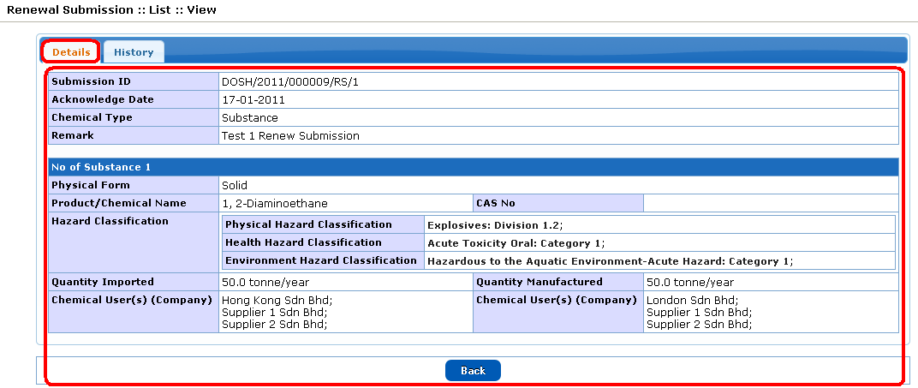

• Details of all list renewal submission

• History of all list renewal submission

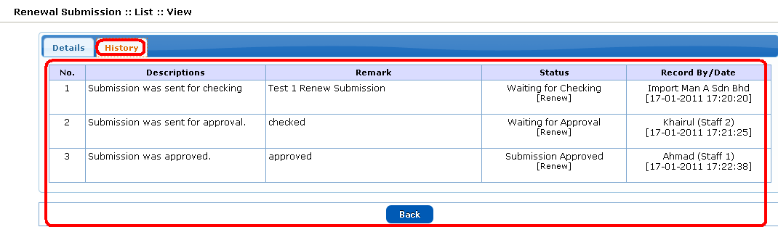

**Report**

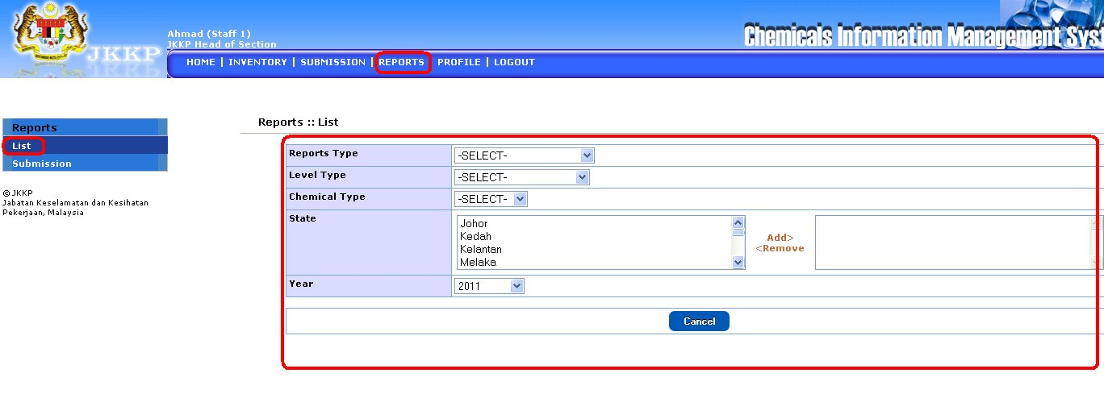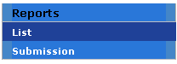

Report sub menu

• Select report type, level type, chemical type, state and year. Click submit button when complete.

• Select report type, level type, chemical type, status, state and year. Click submit button when complete.

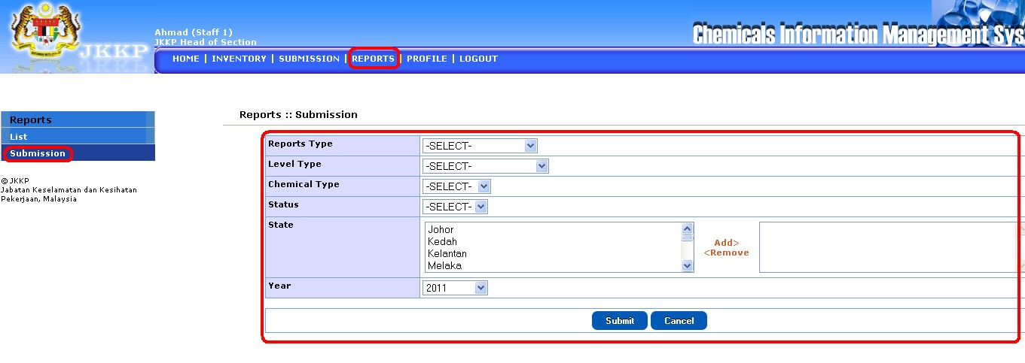

**Profile**

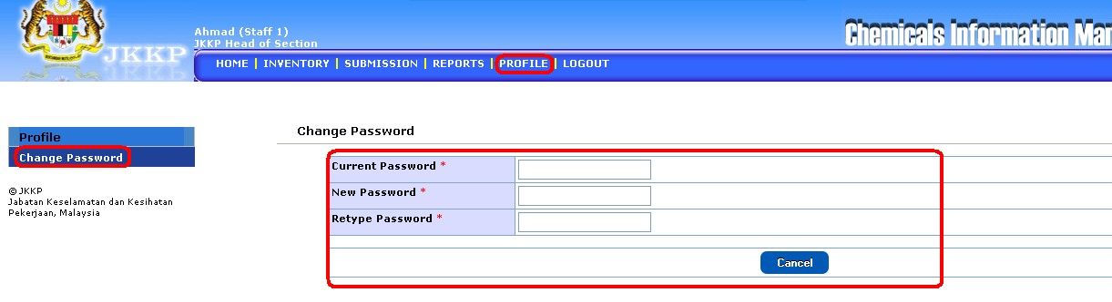

• Change password (if required).